**Global Super Store Sales Analysis sql query**

**A.KPI’S**

**1.Find the total sales:**

select sum(sales)as total_sales from orders;

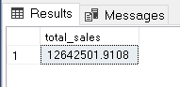

**2.Find the total profit:**

select sum(profit)as total_profit from orders;

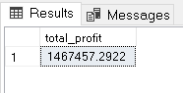

**3.Find the average delivery days:**

select avg(cast(datediff(day,order_date,ship_date)as decimal (10,2)))avg_delivery_days from orders;

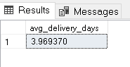

**4.Find the total product returned:**

select count(returned)as product_returned from returns;

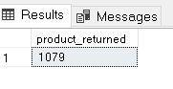

**5.Find the YOY growth percentage:**

WITH sales_detail AS (

SELECT

YEAR(order_date) AS OrderYear,

SUM(sales) AS TotalSales

FROM orders

GROUP BY YEAR(order_date)

)

SELECT

s1.OrderYear AS CurrentYear,

s1.TotalSales AS CurrentYearSales,

s2.OrderYear AS PreviousYear,

s2.TotalSales AS PreviousYearSales,

ROUND(((s1.TotalSales - s2.TotalSales) / s2.TotalSales) * 100, 2) AS YOY_sales_growth

FROM sales_detail s1

JOIN sales_detail s2 ON s1.OrderYear = s2.OrderYear + 1

order by CurrentYear asc;

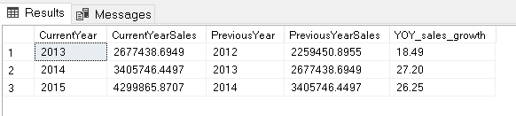

**B.LINE CHART**

**1.Find the total sales trends months wise:**

select year(order_date)as years,month(order_date)as months,sum(sales)as total_sales from orders group by year(order_date),month(order_date)order by years,months asc;

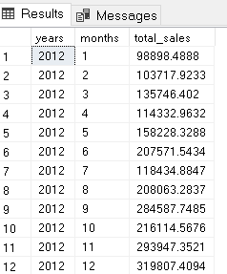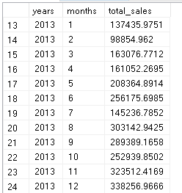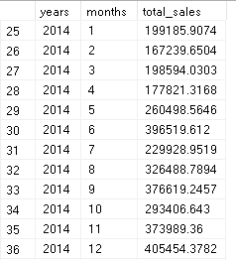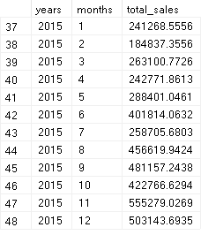

**2.Find the total orders trends months wise:**

select year(order_date)as years,month(order_date)as months,count(order_id)as total_orders from orders group by year(order_date),month(order_date)order by years,months asc;

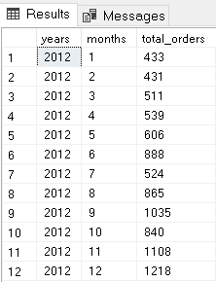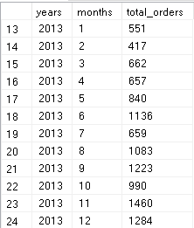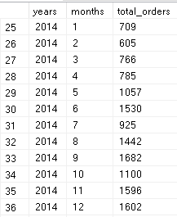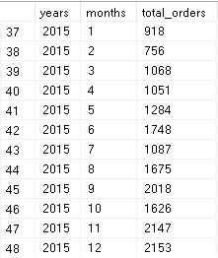

**C.CLUSTERED COLUMN CHART**

**1.Find the total sales by market and category.** (market is Asia Pecific and category is furniture)

select market,category,round(sum(sales),2)as total_sales from orders where market='Asia Pacific' and category='furniture' group by market,category;

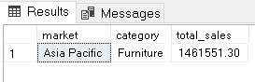

**Find the total sales by market and category.** (Market is Asia Pecific and Category is OfficeSupplies)

select market,category,round(sum(sales),2)as total_sales from orders where market='Asia Pacific' and category='Office Supplies' group by market,category;

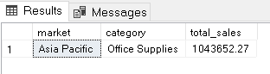

**Find the total sales by market and category.** (Market is Asia Pecific and Category is Technology)

select market,category,round(sum(sales),2)as total_sales from orders where market='Asia Pacific' and category='Technology' group by market,category;

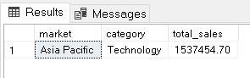

**2.Find the total sales by market and category.**(Market is Europe and Category is Furniture)

select market,category,round(sum(sales),2)as total_sales from orders where market='Europe' and category='furniture' group by market,category;

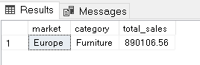

**Find the total sales by market and category.** (Market is Europe and Category is OfficeSupplies)

select market,category,round(sum(sales),2)as total_sales from orders where market='Europe' and category='Office Supplies' group by market,category;

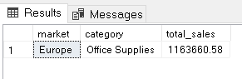

**Find the total sales by market and category.** (Market is Europe and Category is Technology)

select market,category,round(sum(sales),2)as total_sales from orders where market='Europe' and category='Technology' group by market,category;

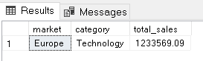

**3.Find the total sales by market and category.**(Market is USCA and Category is Furniture)

select market,category,round(sum(sales),2)as total_sales from orders where market='USCA' and category='furniture' group by market,category;

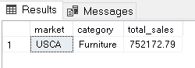

**Find the total sales by market and category.**(Market is USCA and Category is OfficeSupplies)

select market,category,round(sum(sales),2)as total_sales from orders where market='USCA' and category='Office Supplies' group by market,category;

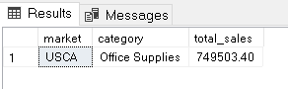

select market,category,round(sum(sales),2)as total_sales from orders where market='USCA' and category='Technology' group by market,category;

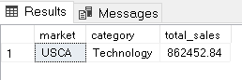

**4.Find the total sales by market and category.**(Market is Latam and Category is Furniture)

select market,category,round(sum(sales),2)as total_sales from orders where market='Latam' and category='furniture' group by market,category;

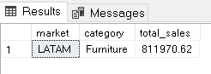

**Find the total sales by market and category.**(Market is Latam and Category is OfficeSupplies)

select market,category,round(sum(sales),2)as total_sales from orders where market='Latam' and category='Office Supplies' group by market,category;

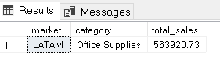

**Find the total sales by market and category.**(Market is Latam and Category is Technology)

select market,category,round(sum(sales),2)as total_sales from orders where market='Latam' and category='Technology' group by market,category;

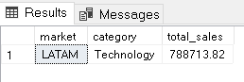

**5.Find the total sales by market and category.**(Market is Africa and Category is Furniture)

select market,category,round(sum(sales),2)as total_sales from orders where market='Africa' and category='furniture' group by market,category;

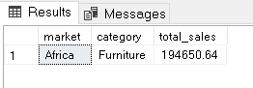

**Find the total sales by market and category.**(Market is Africa and Category is OfficeSupplies)

select market,category,round(sum(sales),2)as total_sales from orders where market='Africa' and category='Office Supplies' group by market,category;

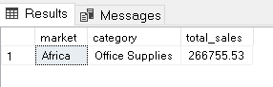

**Find the total sales by market and category.**(Market is Africa and Category is Technology)

select market,category,round(sum(sales),2)as total_sales from orders where market='Africa' and category='technology' group by market,category;

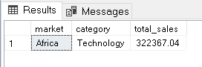

**Total sales by sub-categories?**

select sub_category, round(sum(sales),2)as total_sales from orders group by sub_category order by total_sales desc;

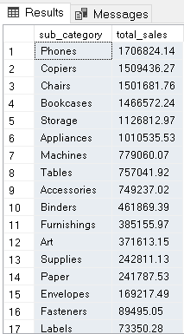

**D.CLUSTERED COLUMN CHART**

**1.Find the total profit by market and category.**(Market is Europe and Category is Furniture)

select market,category,round(sum(profit),2)as total_profit from orders where market='europe' and category='furniture'group by market,category;

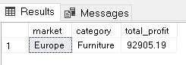

**Find the total profit by market and category.**(Market is Europe and Category is OfficeSupplies)

select market,category,round(sum(profit),2)as total_profit from orders where market='europe' and category='Office Supplies'group by market,category;

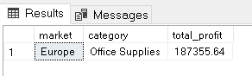

**Find the total profit by market and category.**(Market is Europe and Category is Technology)

select market,category,round(sum(profit),2)as total_profit from orders where market='europe' and category='Technology'group by market,category;

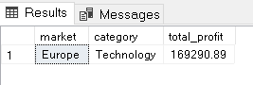

**2.Find the total profit by market and category.**(Market is Asia Pacific and Category is Furniture)

select market,category,round(sum(profit),2)as total_profit from orders where market='asia pacific' and category='furniture'group by market,category;

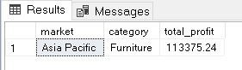

**Find the total profit by market and category.**(Market is Asia Pacific and Category is OfficeSupplies)

select market,category,round(sum(profit),2)as total_profit from orders where market='Asia pacific' and category='Office Supplies'group by market,category;

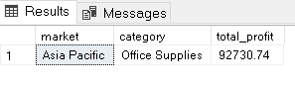

**Find the total profit by market and category.**(Market is Asia Pacific and Category is Technology)

select market,category,round(sum(profit),2)as total_profit from orders where market='Asia pacific' and category='Technology'group by market,category;

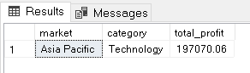

**3.Find the total profit by market and category.**(Market is USCA and Category is Furniture)

select market,category,round(sum(profit),2)as total_profit from orders where market='USCA' and category='furniture'group by market,category;

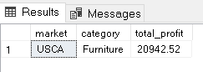

**Find the total profit by market and category.**(Market is USCA and Category is OfficeSupplies)

select market,category,round(sum(profit),2)as total_profit from orders where market='USCA' and category='Office supplies'group by market,category;

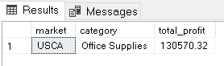

**Find the total profit by market and category.**(Market is USCA and Category is Technology)

select market,category,round(sum(profit),2)as total_profit from orders where market='USCA' and category='Technology'group by market,category;

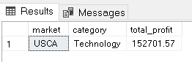

**4.Find the total profit by market and category.**(Market is Latam and Category is Furniture)

select market,category,round(sum(profit),2)as total_profit from orders where market='Latam' and category='furniture'group by market,category;

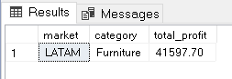

**Find the total profit by market and category.**(Market is Latam and Category is OfficeSupplies)

select market,category,round(sum(profit),2)as total_profit from orders where market='Latam' and category='Office Supplies'group by market,category;

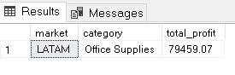

**Find the total profit by market and category.**(Market is Latam and Category is Technology)

select market,category,round(sum(profit),2)as total_profit from orders where market='Latam' and category='Technology'group by market,category;

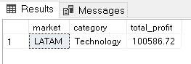

**5.Find the total profit by market and category.**(Market is Africa and Category is Furniture)

select market,category,round(sum(profit),2)as total_profit from orders where market='Africa' and category='furniture'group by market,category;

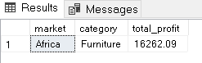

**Find the total profit by market and category.**(Market is Africa and Category is OfficeSupplies)

select market,category,round(sum(profit),2)as total_profit from orders where market='Africa' and category='Office Supplies'group by market,category;

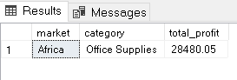

**Find the total profit by market and category.**(Market is Africa and Category is Technology)

select market,category,round(sum(profit),2)as total_profit from orders where market='Africa' and category='Technology'group by market,category;

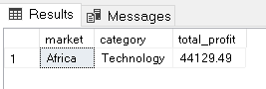

**Find the total sales by sub-categories.**

select sub_category, round(sum(profit),2)as total_profit from orders group by sub_category;

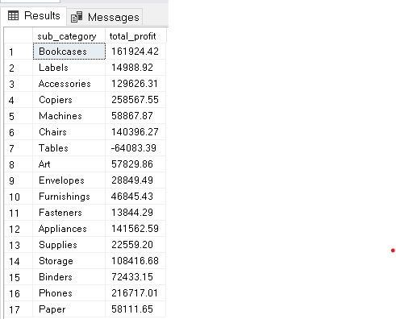

**E.DONUT CHART**

**1.Find total shipping cost:**

select round(sum(shipping_cost),2)as total_shipping_cost from orders;

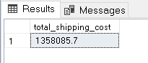

**2.Find the total shipping cost by segment:**

select segment,round(sum(shipping_cost),2)as ship_cost from orders group by segment;

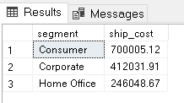

**F.DONUT CHART**

**1.Find the total discount:**

select round(sum(discount),2)as total_discount from orders;

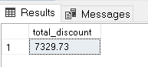

**2.Find the total discount by category:**

select category,round(sum(discount),2)as total_discount from orders group by category;

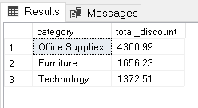

**I.STACKED BAR CHART**

**1.Find the top 10 customer’s name with maximum orders:**

SELECT TOP 10 customer_name, COUNT(order_id) AS Total_orders

FROM orders

GROUP BY customer_name

ORDER BY Total_orders DESC;

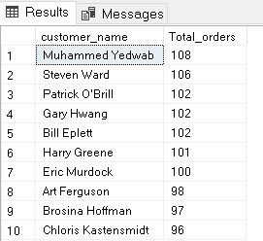

**2.Find the total profit by product name:**

select top 10 product_name,sum(profit)as total_profit from orders group by product_name order by total_profit desc;

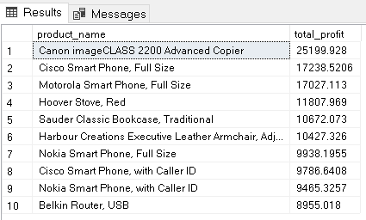

**3.Find the total loss by product name:**

select top 10 product_name,sum(profit)as total_loss from orders group by product_name order by total_loss asc;

